Turning Tool ISO code system

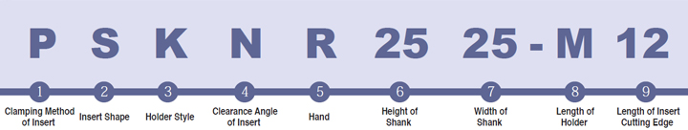

Clamping Method of Insert
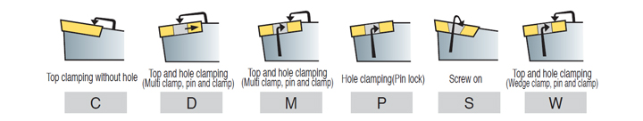

Insert Shape
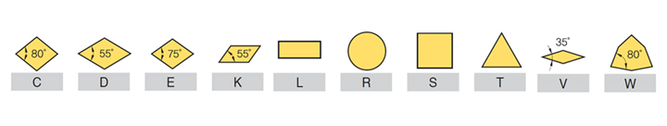

Holder Style
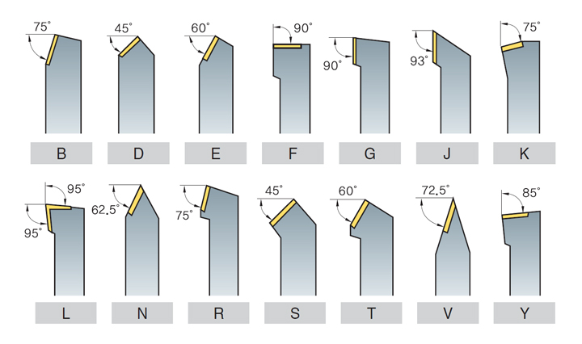
Clearance Angle of Insert
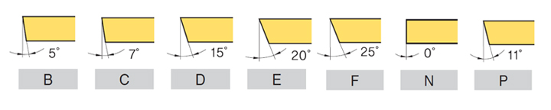

Hand of Tool Holder

Height of Shank (mm)

Width of Shank (mm)

Length of Holder
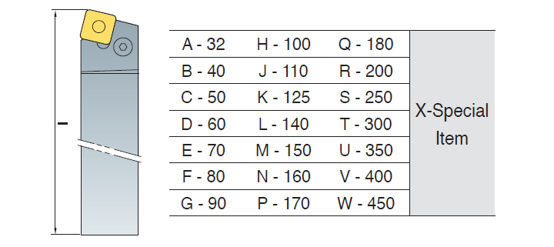

Length of Insert Cutting Edge (mm)
